In Class Assignment 1: Computing Machine Epsilon

Introduction
Machine epsilon or machine precision is an upper bound on the relative approximation error due to rounding in floating point number systems. This value characterizes computer arithmetic in the field of numerical analysis, and by extension in the subject of computational science. The quantity is also called macheps and it has the symbols Greek epsilon ε.[1]
In this assignment, we are tasked with finding the machine epsilon of our device and then verifying our result with the given macheps constants in C++ library.

Source Code
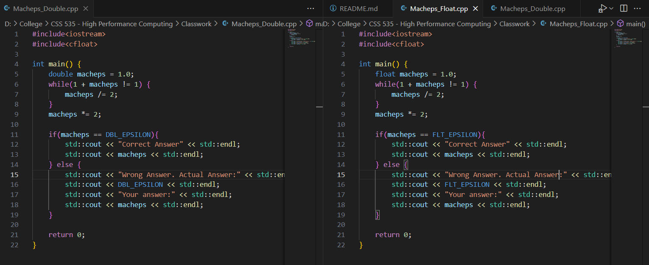
The image shows two source codes, one for float implementation of finding macheps and the other for double.
To compile the program, you can use the commands:
- g++ Macheps_Float.cpp -o Macheps_Float && Macheps_Float
- g++ Macheps_Double.cpp -o Macheps_Double && Macheps_Double

Explanation
The pseudo code for the algorithms was:
- Set variable macheps to 1
- Start a while loop, with condition 1 + macheps != 1
- If condition fails, halve the value of macheps
- Once the loop condition is satisfied, double the value of macheps as that will be the smallest representable value, aka, macheps.
The reason for halving the value of macheps in each iteration is to find the smallest floating-point number which can be added to 1 and the result could be represented by the machine. Halving the number from 1 will shorten the range each time.

References
[1] “Machine epsilon,” Wikipedia. Dec. 28, 2024. Accessed: Jan. 17, 2025. [Online]. Available: https://en.wikipedia.org/w/index.php?title=Machine_epsilon&oldid=1265794028

